|  |
| --- |
|  |
| Newborn Birthweight Prediction  A Statical Analysis |
| |  |  |  | | --- | --- | --- | | Shivam Choudhary (100949298) | 4/16/25 | Statistical and Predictive Modeling I (DATA 1204-03) Professor: Fatma Tetikoglu | |

Table of Contents

R Code 2

References 4

# R Code

library(ggplot2)

library(psych)

head(Birthweights)

describe(Birthweights)

x=Birthweights$bwt

h<-hist(x, breaks=10, col="red", xlab="bwt",

main="Histogram of Birthweights with Density Curve")

xfit<-seq(min(x),max(x),length=40)

yfit<-dnorm(xfit,mean=mean(x),sd=sd(x))

yfit <- yfit*diff(h$mids[1:2])*length(x)

lines(xfit, yfit, col="blue", lwd=2)

t.test(Birthweights$bwt, mu=3400)

simple.fit<-lm(bwt ~ smoke, data=Birthweights)

LinearModel<-simple.fit

summary(LinearModel)

full.model <- lm(bwt ~ gestation + region + age + height + weight + smoke, data = Birthweights)

summary(full.model)

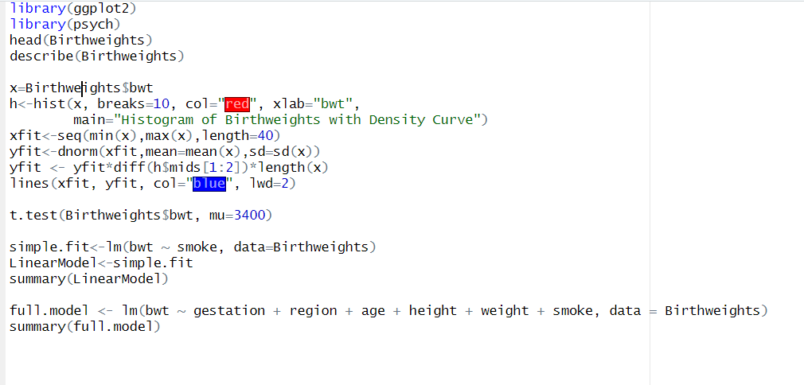

(Tetikoglu, 2025) (Tetikoglu, Week7-Data1203, 2025) (Tetikoglu, Week12-Data1204, 2025) (Tetikoglu, Week13-Data1204, 2025)

# References

Tetikoglu, F. (2025). *Week12-Data1204*. Retrieved April 16, 2025, from Durham College DC Connect: https://durhamcollege.desire2learn.com/d2l/le/content/591135/viewContent/8313762/View

Tetikoglu, F. (2025). *Week13-Data1204*. Retrieved April 16, 2025, from Durham College DC Connect: https://durhamcollege.desire2learn.com/d2l/le/content/591135/viewContent/8313765/View

Tetikoglu, F. (2025). *Week2-Data1204*. Retrieved April 16, 2025, from Durham College DC Connect: https://durhamcollege.desire2learn.com/d2l/le/content/591135/viewContent/8313739/View

Tetikoglu, F. (2025). *Week7-Data1203*. Retrieved April 16, 2025, from Durham College DC Connect: https://durhamcollege.desire2learn.com/d2l/le/content/591135/viewContent/8313750/View